DCO 5.3 SP5 client installation on a Vista machine

Step 1: Invoke the DCO client Installer. This opens the following Welcome screen.

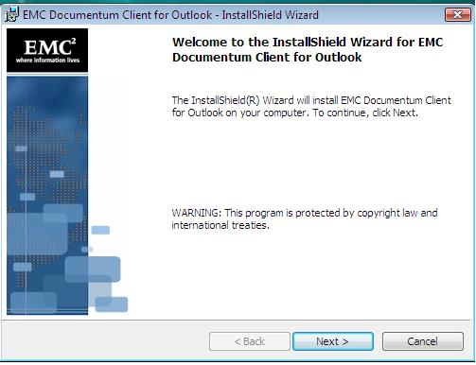

Step 2: In the following screen select to install DCO client application on the machine either for all users or current user only.

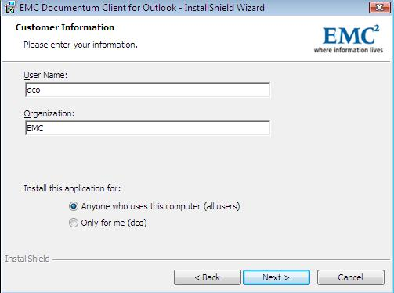

Step 3: Enter the DCO server URL

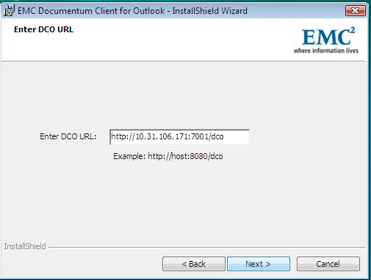

Step 4: Ready to begin installation screen allows us to review the entries in the previous screens.

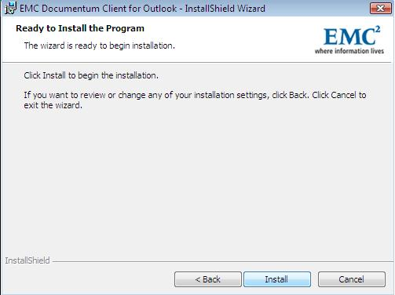

Step 5: Screen that shows the installation status.

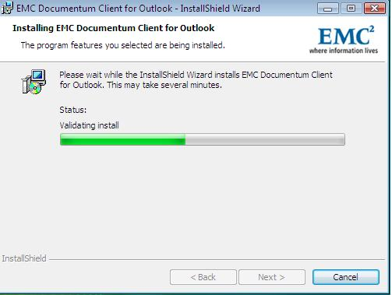

Step 6: Finish button on the following screen completes the installation

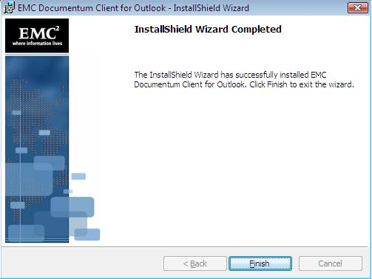

After installing DCO 5.3 SP5 on a Vista machine, User Account Control option (from control panel) should be turned off to work UCF properly.

